Power-Sim Toolbox Guide

Roger Strong & George Alvarez

Harvard University

Contents

General Overview 3

Pilot Data Examples

* T-Test data (1 factor designs) 4
* ANOVA data (2 factor designs) 5

Key Components 6

Example Scripts and Output 8

Warnings 9

General Overview

1. Download the Power-Sim Toolbox by clicking either the .zip or tar.gz link at the top-right of the github landing page
2. Once you unzip the PowerSim folder, open up one of the example files (tTest or ANOVA).
3. Change prefs.csv_file to access your pilot data (see *Pilot Data Examples* later in this guide, or check out the [tutorial video](https://youtu.be/kiN5YjR_zOE))
4. Change the rest of the prefs variable fields to match your desired simulation settings (see *Key Components* later in this guide for a description of each *prefs* parameter, or check out the [tutorial video](https://youtu.be/kiN5YjR_zOE)).
5. After running all your script and all simulations are complete, you will see a plot of your pilot data and a power heatmap for your simulated designs.
6. Additionally, a variable in matlab (power_results) will be available when the simulation is complete, where you can view detailed info about each simulated design (for example, how many subjects/trials you had per condition, distribution of effect sizes, etc.)

Pilot Data Examples

1. **Data for t-tests** (1 factor designs)
   * .csv file should have a header row with labels for subject id (here *Subject*), dependent variable name (here *Accuracy*), and condition (here *Condition*). Headers only used for plotting and can be whatever text you like, but must be in this order:
     + A) Subject ID | B) dependent variable | C) Condition
   * Each row after the header should be an individual trial
     + first column specifies the subject id (can be a number or string ID)
     + second column specifies the dependent variable value for that trial (i.e., what was measured). Here I have 1/0 for correct or incorrect. Should be a numerical value (1/0 for accuracy, a reaction time, rating, etc)
     + third column specifies which condition was assessed on that trial (condition names can be a string or number)

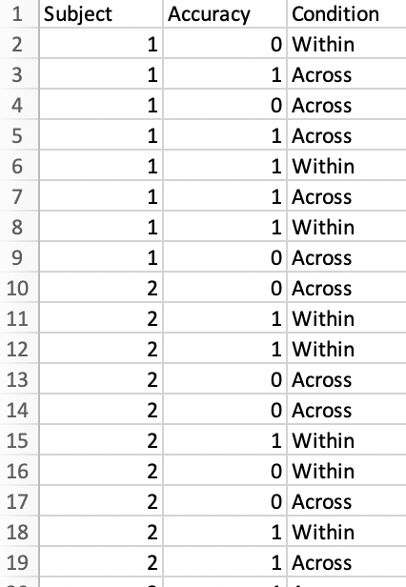

1. **Data for ANOVAs** (currently only 2 factor designs supported)
   * .csv file should have a header row with labels for subject id (here *Subject*), dependent variable name (here *Accuracy*), Factor 1 Name (here *Movement Type*) and Factor 2 Name (here *Direction*). Headers only used for plotting and can be whatever text you like, but must be in this order:
     1. A) Sub ID, B) DV, C) Factor 1, D) Factor 2
   * Each row after the header should be an individual trial
     1. first column specifies the subject (can be a number or string ID)
     2. second column specifies the dependent variable value for that trial (i.e., what was measured). Here I have 1/0 for correct or incorrect. Should be a numerical value (1/0 for accuracy, a reaction time, rating, etc)
     3. third column specifies which level of factor 1 was assessed on that trial (factor level names can be a string or number)
     4. fourth column specifies which level of factor 2 was assessed on that trial

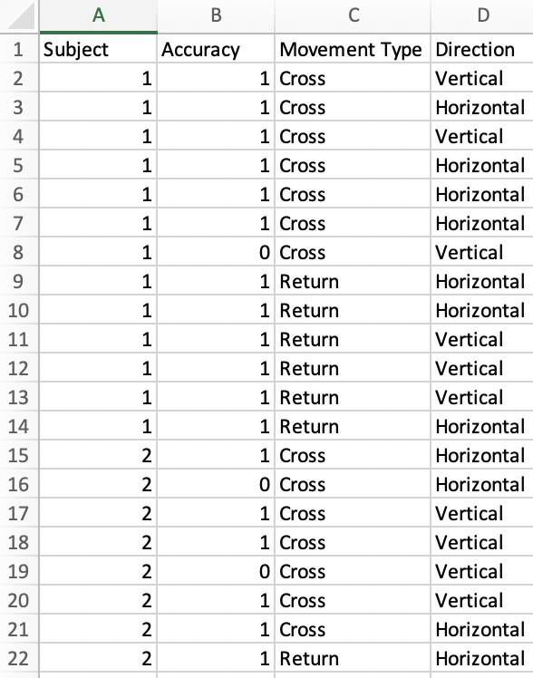

Key Components (page 1 of 2)

* prefs.csv_file
  + Name of a CSV file containing your data
  + Top row of CSV contains column headings (used for pilot graph); each additional row in CSV file is a trial
  + For t-tests (1 factor designs), you should have 3 columns: Col 1 = sub ID, Col 2 = trial score, Col 3 = condition
  + For ANOVAs (2 factor design), you should have 4 columns: Col 1 = sub ID, Col 2 = trial score, Col 3 = factor 1 level, Col 4 = factor 2 level
* prefs.show_pilot_data_only
  + set to true if you only want to produce the pilot data graph (and not run the power simulation). Set to false otherwise
* prefs.N_range
  + Range of number of participants to simulate. E.g., 10:10:50 will simulate with 10, 20, 30, 40, and 50 participants. This is TOTAL number of participants (not number of subjects for condition, although these are equivalent for within-subjects designs)
* prefs.trial_range
  + Range of number of trials per condition to simulate. E.g., 8:4:24 will simulate with 8, 12, 16, 20, and 24 trials per condition
  + Can also do an uneven number of trials per condition, by specifying a separate range for each condition in your design
    - Instead of entering a vector range, you would enter a matrix where rows correspond to each condition, and columns correspond to each design
    - for example, if you have two conditions and wish to simulate a 2:1 trial ration, you could enter [8:4:24; 4:2:12]
  + note that your pilot data may have any number of trials per condition (which you do *not* have to specify) – you only need to specify the number of trials per condition of the designs you wish to simulate
* prefs.alpha
  + Significance level to use in simulations (often .05)
* prefs.nSims
  + How many simulations to use for every participant/trial number combination. 10,000 is a decent estimate and runs pretty quickly, 100,000 is slower but a more stable estimate.

Key Components (page 2 of 2)

* prefs.comps
  + Which comparisons to test for significance. Each row is a comparison, with the condition expected to be higher magnitude listed in the first column, and the condition expected to have lower magnitude in the second column.
  + A study will be classified as “successful” only if all listed comparisons are significant (see examples).
  + To make sure you have specified the condition comparisons correctly, please view plot of pilot data (and make sure conditions are numbered in the order you expect)
* prefs.condition_allocation
  + Used only for between-subjects designs (ignored otherwise). Ratio of how total number of subjects should be divided between conditions during simulations.
  + Should be a value for each condition in data, and values should sum to 1 (100%). For example, [.5, .5] would divide subjects evenly between two conditions. [.25, .5, .25] would use a 1:2:1 ratio for dividing subjects between 3 conditions.
  + If you wish to have your total N divided evenly between all between-subjects conditions, you can set this variable equal to the string ‘even’
  + To make sure you have specified the condition allocation correctly, please view plot of pilot data (and make sure conditions are numbered in the order you expect)
  + Note that your pilot data may have any condition allocation ratio (which you do *not* need to specify) – you only need to specify the condition allocation ratio for the designs you wish to simulate.
* prefs.exclusion_min, prefs.exclusion_max
  + Exclude subjects whose overall score (across all conditions) is less than pref.exlcusion_min or greater than prefs.exclusion_max.
  + Excluded subjects will be replaced, so that requested N is achieved (planning on giving option to not replace excluded subjects in a future version)
* prefs.sig_ME1, prefs.sig_ME2, prefs.sig_int
  + For ANOVAs (2-factor designs), whether significant main effects for either factor or a significant interaction is necessary for a successful study design.
  + Note that for mixed-factor design, the between-subjects factor is always considered the first factor (prefs.sig_ME1).
  + Set equal to true (or 1) if successful study requires significant effect

Example Scripts and Output

* Within the toolbox, you will see a number of example scripts that you can edit to simulate your candidate experimental designs and analysis plans
* Note that you do NOT need to specify whether your design is within or between subjects – the toolbox detects this automatically from the structure of your pilot data.
* Note that in both scripts and heatmaps, sample size indicates TOTAL sample size, not sample size per condition. Although these values are the same for purely within-subjects designs (where every subject has a score for every condition), the values are not the same for between-subjects designs
* The t-test examples show various ways to edit different options within prefs (i.e., exclusion criteria, uneven trial allocation, uneven condition allocation, multiple comparisons) – these changes can also be made when simulating ANOVAs
* see [tutorial video](https://youtu.be/kiN5YjR_zOE) for a detailed overview of the example scripts within the toolbox

Warnings

* use at your own risk! Although we have attempted to test our code thoroughly, we cannot guarantee it is bug-free. This code is meant to be an example of how to go about bootstrapping pilot data, which we hope will motivate others to write their own code for simulating power analyses (as well as to contribute to our toolbox)
* We provide code for relatively simple designs (within or between subjects t-tests, and within, between, or mixed-factor ANOVAs with 2 factors). In the future we (or others) may add more functionality. Bootstrapping can be applied to any design – researchers just need to write resampling code that is specific to their design and analysis plan
* Simulating purely between-subjects ANOVAs will not work on MATLAB versions 2016 or earlier. Simulating T-Tests and within- or mixed-factor ANOVAs should would on MATLAB versions 2016 and later (and possibly earlier, but has not been tested).
* With very large combinations of trial numbers and sample size, the code will sometimes run relatively slowly. However, most designs (in the hundreds of trials/subjects) should take no longer than a few minutes to run.